**2. Selection Problems (IF ELSE, ELIF)**

**Task 3:**

**Plan:**

1. Users “name” is Defined, variable “valid” is defined with Boolean data type True.
2. “Height” and “mass” variable defined, storing input as integer from user. Both variables are validated, error message is displayed and user is asked to enter values again, if data types is not an integer.
3. BMI is calculated and stored in variable “bmi”.
4. “bmi” is checked against 5 conditions, variable “weight” is defined differently depending on condition.
5. “Name”, “weight”, and “bmi” is output.

**Pseudocode:**

Name 🡸 input (“Enter your Name:”)

Valid 🡸 True

While valid = True:

Try:

Height 🡸 input as integer (“Enter your height in CM”)

Mass 🡸 input as integer (“Enter your weight in KG”)

Valid 🡸 False

Except:

Print ("invalid, input!")

Bmi 🡸 (mass / (height/100 * height/100))

If bmi <= to 18.5:

Weight 🡸 “underweight”

Else if bmi in range (18.6, 24.9):

Weight 🡸 “healthy weight”

Else if bmi in range (25, 29.9):

Weight 🡸 “overweight”

Else if bmi in range (30, 39.9)

Weight 🡸 “obese”

Else if bmi >= 50:

Weight 🡸 “very obese”

Print (name, "You are", weight, "Your BMI is", bmi)

**variables table:**

|  |  |  |
| --- | --- | --- |
| Variable name | Data type | comment |
| Name | String | Stores name of user |
| Valid | Boolean | Stores value True |
| Height | Integer | stores users height input |
| Mass | Integer | Stores users weight input |
| Bmi | Float | Stores calculated bmi value |
| Weight | String | Stores string that tells user if there “obese” or “under weight” for example. |

**Screenshot evidence:**

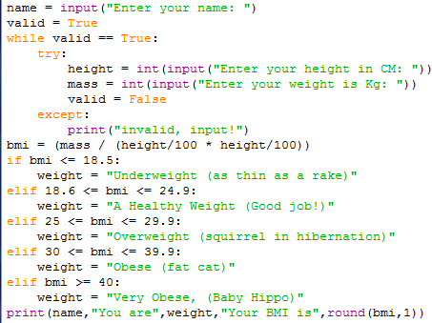in the screenshot to the left as you can see, name is defined flowed by valid with Boolean Value True. A while loop then validates “height” and “mass”, and a print statement is displayed if necessary. Next the bmi is calculated, and compared to 5 conditions. 1) bmi is less than 18.5, 2) bmi in range 18.6 to 24.9, 3) bmi is in range 25 to 29.9, 4) bmi is in range 30 to 39.9, 5) bmi is over 39.9.

**Sample run (Output):**

Underweight:

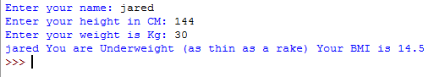

Health weight:

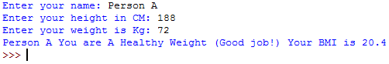

Overweight:

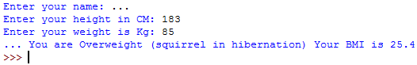

Obese:

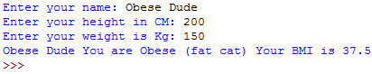

Very obese:

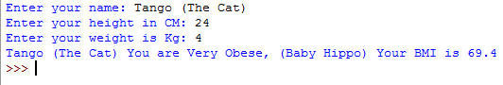

**Flow charts:**

START

Name 🡸 input (“Enter your Name :”)

Valid 🡸 True

Yes

Valid 🡸 False

Height 🡸 input as int

Bmi 🡸 (mass / (height/100 * height/100))

Mass 🡸 input as int

Is Height and mass an integer?

No

A

A

Yes

Yes

Yes

Yes

No

No

No

Is bmi in range 30 to 39.9

Is bmi in range 25 to 29.9

Is bmi in range 18.6 to 24.9

Is bmi <= 18.5

Weight 🡸 “Under Weight”

Yes

Else bmi >= 40

Print (name, "You are", weight, "Your BMI is", bmi)

Weight 🡸 “Very Obese”

Weight 🡸 “Obese”

Weight 🡸 “Overweight”

Weight 🡸 “A Healthy Weight”

No

END